APPENDIX A

The classical Hall effect

The classical Hall effect is a phenomenon involving electrically conducting crystals. It explains the emergence of an electric field, known as the Hall field 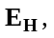owing to the residual displacement of electrons originating from an applied current, of density j. The magnitude and orientation of this field is such as to exactly counteract the effects of a steady, uniform magnetic flux B, orientated perpendicularly to the applied current.

Consider the experimental arrangement displayed in Fig. A1.

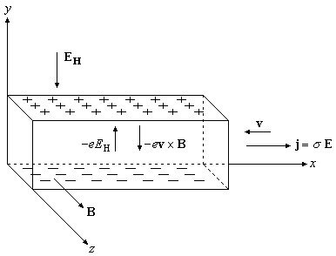

Fig. A1 Geometry of the classical Hall effect. A conducting crystal is subjected to a uniform magnetic flux B and an orthogonal current of density j. The Lorentz force 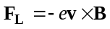, induces opposing electrical charges on the two surfaces orthogonal to the axis of the force, giving rise to the Hall field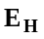, which exerts a force 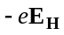 that exactly balances the Lorentz force (adapted from [3], §3.3.5).

The steady state equation of motion for the electrons in the crystal is

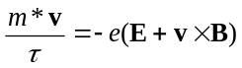, 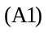

where m* is the electron effective mass and is the drift velocity of the electrons, acquired by virtue of the non-equilibrium nature of the system, owing to the presence of electric and magnetic fields and ( [4], §3.3.1). Each electron is considered to be unhindered in its motion within the crystal up until a characteristic timeknown as the mean scattering time, at which point they undergo scattering.
From the above, we must have 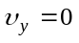in steady state, and clearly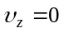since there is no contribution to electron motion in this direction, either by the Lorentz force or by the applied current. Thus, the components of (A1) are then

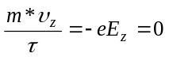, 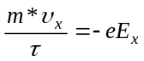 and 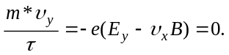 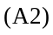

The z and x components of (A1) indicate that there is no deviation from the Ohm law in these directions, whilst the y component gives us an explicit relation for the electric field

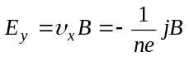. 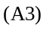

In our original definition of the Hall field, we define it to be the electric field with magnitude and direction that exactly cancels the Lorentz force on the electrons. From Fig. A1 we see that the only component of the Hall field is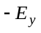, whilst the only other non-zero component of the electric field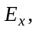 owes its existence entirely to the presence of the applied current. Thus we have

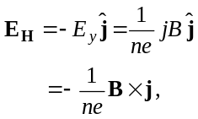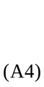

where n is the electron number density.
We can then define the Hall field in terms of the Hall coefficient R_{H}

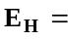R_{H}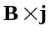 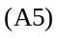

which implies that

R_{H}